Chemistry 115 Name
Dr. Cary Willard
Exam 1C February 23, 2009

 | Points Earned | Points Possible
Part 1  multiple choice |  | 30
Part 2  nomenclature |  | 10
Page 3 |  | 28
Page 4 |  | 18
Page 5 |  | 14
Total |  | 100

Note: All work must be shown to receive credit. On calculation problems show answer with the correct number of significant figures using scientific notation if necessary.
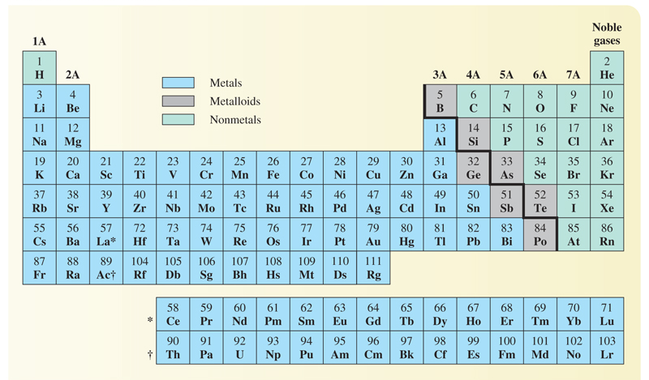
Part 1 – Multiple Choice (30 points)

- Why study chemistry?
  - To help us learn a technique for identifying and solving problems
  - To understand the behavior of materials
  - To help inform us about our world
  - To be better able to make informed decisions
  - All the above

- Which is a scientific observation?
  - Water freezes at zero degrees C
  - Freezing and boiling are called physical changes
  - If a substance has a density of 1.00g/mL it must be water.
  - When a substance freezes its molecules lose potential energy.
  - All of the above are scientific observations

- A well established hypothesis is often called a(n)

  - observation
  - fact
  - law
  - theory

- Which is a pure substance?

  - sugar
  - coffee
  - orange juice
  - mud

- How many significant digits are in the number 1.30 X 10⁴?

  - 1
  - 2
  - 3
  - 4

- The number, 14.74999, when rounded to three digits is

  - 10.0
  - 14.7
  - 15.0
  - 14.8

- One kilometer is equal to

  - 1000m
  - 100m
  - 0.001m
  - 0.01m

- When expressed in proper scientific notation the number 0.000034 is

  - 3.4 X 10⁻⁵
  - 34 X 10⁻⁴
  - 3.4 X 10⁻⁴
  - 3.4 X 10⁴
  - 3.4 X 10⁵

- Which type of element has the following general properties: low melting point and density, lacks luster, poor conductor of heat and electricity, and brittle?

  - Transition element
  - Metal
  - Metalloid
  - Nonmetal

- The smallest particle of an element that can exist is called a(n)

  - Ferrule
  - Atom
  - Neutron
  - Electron
  - Proton

- How many atoms of hydrogen are present in one molecule of Al(H₂PO₄)₃?

  - 2
  - 3
  - 5
  - 6
  - 7

- Which chemical symbol is properly written?

  - Cu
  - ca
  - CO
  - CL

- The alkali metals are in group

  - 1A
  - 3A
  - 5A
  - 7A

- Which is not a physical property of water?
  - Water is colorless.
  - The density of water at 4º C is 1.00g/mL.
  - Water reacts with sodium metal to produce sodium hydroxide and hydrogen.
  - The freezing point of water is 0º Celsius.
  - All of the above are physical properties of water

- Hydrogen combines with oxygen to form water. If 1.67g of hydrogen combines with 13.33g of oxygen what mass of water will be produced?

  - 16.67g
  - 13.33g
  - 15.00g
  - 11.66g
  - 1.67g

Part 2 – Nomenclature (10 points)

Fill in the following chart with the correct name or formula for the following elements and compounds.

Compound / Element Name | Formula / Elemental Symbol
Phosphorous
Fluorine
 | B
 | Ag
Zinc oxide
Cupric chloride
Sulfur diiodide
 | NBr₃
 | VS₂
 | Na₃P

Part 3 – Problems and Questions (60 points)

- (6 points) Evaluate each of the following expressions. State the answer to the proper number of significant figures.

  - 32.353 + 3.98 + 255.33=

  - $\frac{0.000625}{21.588}$=

- (8 points) Complete the following metric conversions using the correct number of significant figures. Put the answer in correct scientific notation.
  - 6.31 kg to mg

  - 50.3 km to m

- (8 points) Complete the following American / metric conversions using the correct number of significant figures
  - 0.385 m to in

  - 4.81 qt to mL

- (6 points) Complete the following temperature conversion
52 ºC to ºF

- (6 points) After you have worked out at the gym on a stationary bike for 45 minutes, the distance gauge indicates that you have traveled 14.5 miles. What was your rate in km/hr (5280 ft = 1 mile)

- (6 points) Iron has a density of 7.87 g/mL. If 93.4 g of iron is added to 75.0 mL of water in a graduated cylinder, to what volume reading will the water level in the cylinder rise?

What is the volume of the iron? (Hint: Do this part 1st)

- (6 points) A personal trainer uses calipers on a client to determine his percent body fat. After taking the necessary measurements, the personal trainer determines that the client’s body contains 12.5% fat by mass. If the client weighs 115 kg, how many kg of fat does he have?

- (8 points) Give definitions for the terms pure substance and mixture and give two examples of each type of material.

Pure substance

1.
2.
Mixture

1.
2.

- (6 points) Aqueous solutions of the substance nickel(II) sulfate are bright green in color. If an aqueous solution of barium chloride is added to an aqueous solution of nickel(II) sulfate, a white precipitate of barium sulfate forms. Based on the information in the previous paragraph, identify a physical and chemical property of nickel(II) sulfate.

Physical property

Chemical Property

